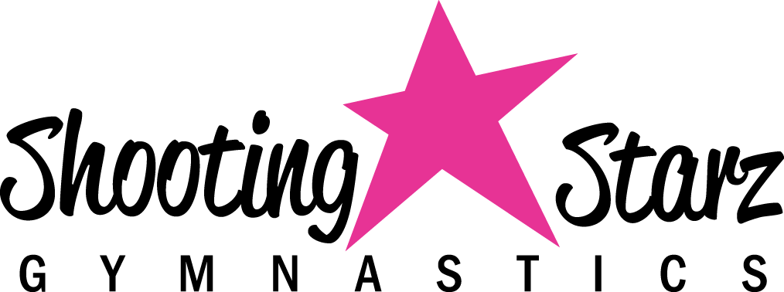

2023 Registration Form
Student Information
Student Name:___________________________ Age:_________ Date of Birth:_______________
Allergies or Medical Conditions: ________________________________________________________
Parent/Guardian Information
Mom/Guardian Name: ______________________________ Phone #: __________________________
Dad/Guardian Name : _______________________________ Phone #: __________________________
Address: ___________________________________ City: ______________________ Zip: ________
Primary Email Address: _________________________________________________________________
Emergency Contact Information
Name: _____________________ Relationship to Child:_______________ Phone #:_________________
Enrollment Information
Class: ___________________________ Day: ______________ Time: ______________________
General Liability Waiver
As the legal guardian of my designated student(s), I hereby consent to all student(s) participating Shooting Starz Gymnastics, LLC program(s). I recognize that potentially severe injuries can occur in any activity involving height or motion, including tumbling and related activities including cheer leading, tumble tramp, trampoline, stunting, dance, gymnastics and physical activity in general. I understand that it is the express intent of all staff and personnel to provide for the safety and protection of my student(s) and, in consideration for allowing my student(s) to use these facilities, I hereby COVENANT NOT TO SUE and FOREVER RELEASE this facility, affiliated and partner companies and organizations, property owners and lessors, staff, contractors, subcontractors, teachers, coaches, owners, directors and other members involved in this facility's program(s), from all liability and for any and all damages and injuries suffered by my student(s) during instruction, supervision, and/or control during any and all classes or extra activities.
The participant shall defend, indemnify, and hold Shooting Starz, its officers, employees, and agents harmless from and against any and all liability, loss, expense, including reasonable attorney’s fees, or claims for injury or damages arising out of the performance of this Agreement but only in proportion to and to the extent such liability, loss, expense, attorney’s fees, or claims for injury or damages are caused by or result from the negligent or intentional acts or omissions of Shooting Starz, its officers, agents or employees. The participant understands that injuries as a result of gymnastics and other activities are the full responsibility of the participant and are not covered in any way by Shooting Starz Gymnastics LLC.
In signing this Agreement, the participant/legal guardian accepts all responsibility for damage, harm, or injury that may occur to the participant or one invited onto the premises by the participant and that Shooting Starz shall have no liability for such harm, damage, or injury.

Parent/Guardian Signature: __________________________________ Date: _________________

I hereby grant Shooting Starz Gymnastics, LLC permission to use my designated student(s) likeness in any photograph, video, or other digital media photo in any and all of its publications, including web-based publications.

Parent/Guardian Signature: __________________________________ Date: _________________

PLEASE TURN OVER FOR ADDITIONAL WAIVER

COVID-19 ACKNOWLEDGMENT, INDEMNITY AND WAIVER AGREEMENT
In consideration of being allowed to participate in any workouts, events, and activities (“Activities”) associated with Shooting Starz Gymnastics LLC. I, as the legal guardian of my designated Student(s) and/or "Participant(s)", acknowledge this COVID-19 ACKNOWLEDGEMENT, INDEMNITY AND WAIVER AGREEMENT (“Agreement”) and agree to be bound by the following:
The Participant and/or legal guardian acknowledges the serious health risks associated with COVID-19 as outlined by the Centers for Disease Control and Prevention (“CDC”), which have resulted in numerous government related mandates, public and private shutdowns, and/or restrictions as a result of those health concerns. Notwithstanding the foregoing, the Participant and/or legal guardian desires to engage in Workouts and Activities associated with Shooting Starz Gymnastics, LLC.
The Participant and/or legal guardian acknowledges and has been advised that of:
- The recommendations of the CDC and the Commonwealth’s guidance which, from time to time, may require the Workouts to be limited or completely halted. In the event we need to halt our gym operations, we will offer class time for participants in the current session affected by the closure, in the form of virtual classes.
- The potential risks associated with the Activities and participating in the Activities, as such risks relate to COVID-19; and
- There have been no representations or guarantees that Shooting Starz Gymnastics LLC, will be free from COVID-19.

The Participant and/or legal guardian represents and warrants to Shooting Starz Gymnastics LLC, that prior to and through the date of this Agreement:
- They have not been diagnosed with COVID-19;
- They have not experienced any symptoms signs of COVID-19;
- They have not been in contact with any individual that has been diagnosed with COVID-19 without communication of this.
The Participant and/or legal guardian acknowledges that any and all claims raised by any third party (“Other Parties”) relating to the risk of or illness from exposure to COVID-19 as a result of the Activities or entry to Shooting Starz Gymnastics LLC, no event be attributed to Shooting Starz Gymnastics LLC.
In addition, participant and/or legal guardian makes the following representations as a condition to voluntary use of the Shooting Starz Gymnastics’ amenities, facilities, or services during the Pandemic:
I understand that the symptoms associated with the novel Coronavirus (COVID-19) include fever, fatigue, dry cough, and shortness of breath, and affirm that I, as well as all household members, do not currently have, nor have experienced the symptoms listed above WITHIN THE LAST 14 DAYS.
I affirm that I, as well as all household members, have not been diagnosed with COVID-19 WITHIN THE PAST 30 DAYS.
I affirm that I, as well as all household members, have not knowingly been exposed to anyone diagnosed with COVID-19 WITHIN THE PAST 30 DAYS.
I affirm that I, as well as all household members, have not traveled outside of the country, or to any city considered to be a "hot spot" for COVID-19 infections WITHIN THE PAST 30 DAYS.
I understand that Shooting Starz Gymnastics LLC cannot be held liable for any exposure to the COVID-19 virus caused by misinformation on this form or the health history provided by each client.
In consideration for Shooting Starz Gymnastics LLC continuing to permit the Participant to engage in Activities, workouts and enter and Shooting Starz Gymnastics LLC, the Participant agrees:
Participant and/or legal guardian agree to release, protect, defend, indemnify, save and hold Shooting Starz Gymnastics LLC and its agents harmless from and against any and all expenses, damages, claims, suits, actions, judgments, losses, costs and expenses whatsoever (including reasonable attorney’s fees, both those incurred in connection with any claim relating to, resulting from or arising out of: (A) an occurrence of COVID-19 by: (i) Participant and/or (ii) any Other Party, claimed to be in connection with and/or as a result of the Participant’s involvement in Activities, workouts or entry to Shooting Starz Gymnastics LLC.; or (B) any claim of exposure to COVID-19 and/or (ii) any Other Party, claimed to be in connection with and/or as a result of the Participant’s involvement in Activities, workouts or entry to Shooting Starz Gymnastics LLC.
Participant and/or legal guardian certifies that they are authorized to enter into this Agreement and acknowledges that it shall be binding upon the Participant and each of their heirs and assigns.

Parent/Guardian Signature: ____________________________________ Date: __________________

