T-Shirt Order Form – 2016
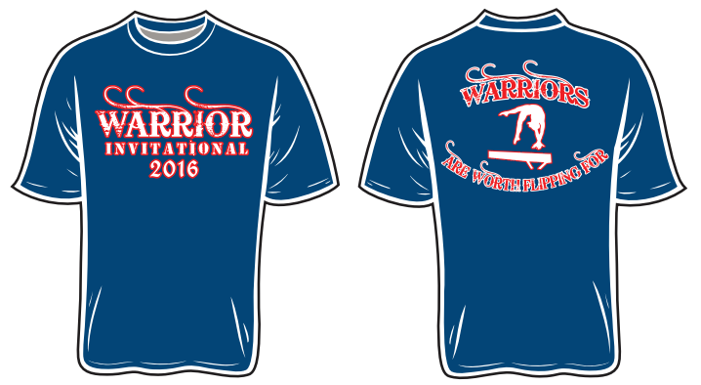
Deadline: October 1st, 2016 (must be received by 10/1, not postmarked)
Payment: Make checks payable to Shooting Starz Gymnastics
Send order forms and payments to: Shooting Starz Gymnastics Warrior Invitational 250 Johnson Street Wilkes-Barre TWP, PA 18702
Front: Warrior Invitational 2016 Back: Warriors Are Worth Flipping For
** Order ahead to ensure you have one; limited quantities on the day of the meet. **
Team: ___________________________________________________________________________________
Gymnast  Name | CXS  $14.00 | CS  $14.00 | CM  $14.00 | CL  $14.00 | CXL  $14.00 | AS  $17.00 | AM  $17.00 | AL  $17.00 | AXL  $17.00 | A2XL  $19.00 | A3XL  $19.00
TOTALS:

